From the administration screen select Logbook Categories. Click on the desired category and then click the “Work With Data Entry Panel”

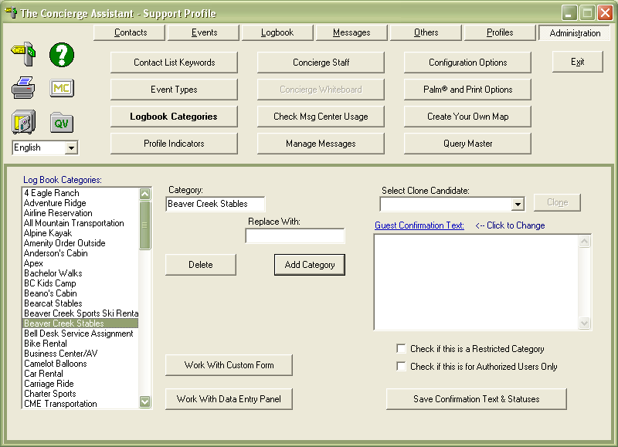

You will see the data entry panel. Create the desired fields by typing in the “Label to be used for information required”. After you type in the label click “Add”, when you finish typing your fields click “Save Data Entry Design”

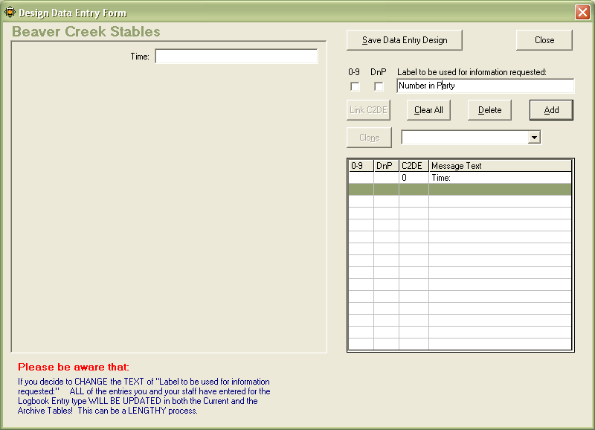

Note. You can make numeric field by selecting the check mark in 0-9 or do not print field by selecting the DnP check box

You can link elements from Contacts by clicking the “Links C2DE” button. (You only will see these button active after you have click the “Add” button)

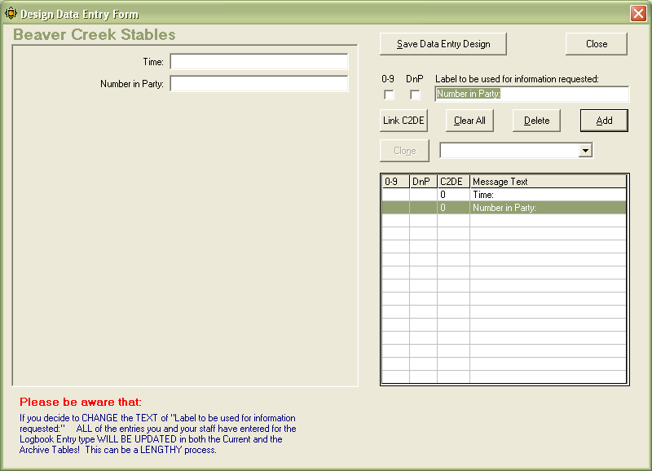

You can link all these elements from Contacts:

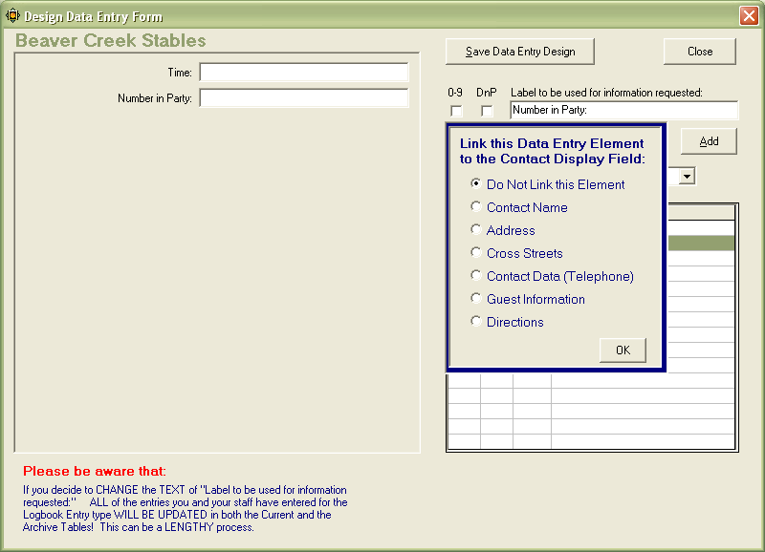

Please see the document “linking directions from Contacts” for more details about this feature.

After you have link the desired elements make sure you click “Add” you will see a number different than “0” in the “C2DE” column. Finally save the data entry and you are all set.

